Brown baseline unified metrics:

 | PES_phrase | RR_phrase | EC_phrase | WES_word | WRS_word | WC_word | first_last_max_phrase_len | first_last_num_matches
0 | 3.571429 | 0.628571 | 2.942857 | 3.085714 | 0.4 | 2.685714 | 5.2 | 3.4

ChatGPT 4 unified metrics:

 | PES_phrase | RR_phrase | EC_phrase | WES_word | WRS_word | WC_word | first_last_max_phrase_len | first_last_num_matches
0 | 7.906463 | 0.435374 | 7.471088 | 5.136905 | 0.131803 | 5.005102 | 8.22619 | 5.279762

ChatGPT 4o-mini unified metrics:

 | PES_phrase | RR_phrase | EC_phrase | WES_word | WRS_word | WC_word | first_last_max_phrase_len | first_last_num_matches
0 | 3.067857 | 0.725 | 2.342857 | 1.8 | 0.307143 | 1.492857 | 5.225 | 3.275

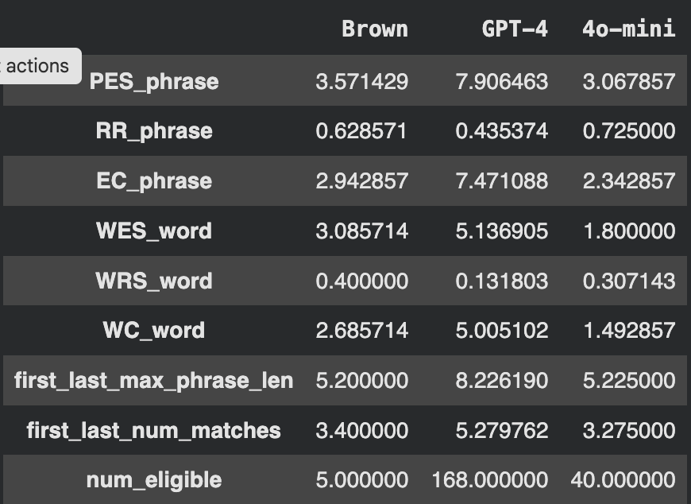

ChatGPT 4:

Total poems: 258
Eligible (exactly 14 lines): 168
Percent eligible: 65.12 %

ChatGPT 4o-mini:
Total poems: 258
Eligible (exactly 14 lines): 40
Percent eligible: 15.5 %

